Simple Documentation to set-up a Workflow in Jenkins

Jenkins:

Jenkins is an open-source automation server that facilitates the continuous integration and continuous delivery (CI/CD) of software projects. It is a widely used tool in DevOps practices to automate the building, testing, and deployment of applications. Jenkins helps streamline and automate the software development lifecycle, making it more efficient and reliable. It offers two types of workflows: 1.Freestyle 2.Pipeline. The workflow helps the user to create a job based on their use-case. I used Freestyle Workflow as it doesn’t require to monitor the version control and good starting point for beginners.

1. Installation of Jenkins

Prerequisites : Java 11,17,21.

1. Download Jenkins from Official Website:

Based on the Operating System/Virtual Machine, download the respective version. I have used Windows Version.

URL : [Jenkins Windows](https://www.jenkins.io/download/thank-you-downloading-windows-installer)

1. Install Jenkins in the Windows:

Install the Jenkins Setup in the preferred folder but I would recommend it to be in default location.

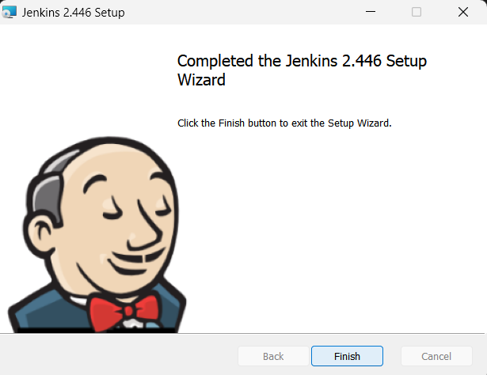

1. Set-Up Jenkins
2. Connect Jenkins in Browser:

The Default Port Number for Jenkins is 8080 and most of the users wouldn’t change it.

Ex: Type <https://localhost:8080> to access Jenkins.

1. Enter your Personal Information:

When setting up newly, Jenkins requires personal information of the users.

1. Install Necessary Plugins:

When launching Jenkins for the first time, it wants to install all the necessary Plugins to work. It requires some time to download and install.

1. Create a job and run
2. Add Item:

Add Job name and select the job type in the selection window.

We choose Freestyle project.

1. Select the job:

Select the job and go to configuration tab to set up the job application.

1. Build the job and run:

In the configuration window, select add build step and select windows batch command as our build. Then, type “echo Hello Jenkins!” in the dialog box. After setting up, go to the dashboard and click on the play button in the Job Name.

1. Check the output:

After running the job, click on the job and go to the build history where you can see the green tick symbol near to our job name. Click the job and navigate to console output where you can see the output.

